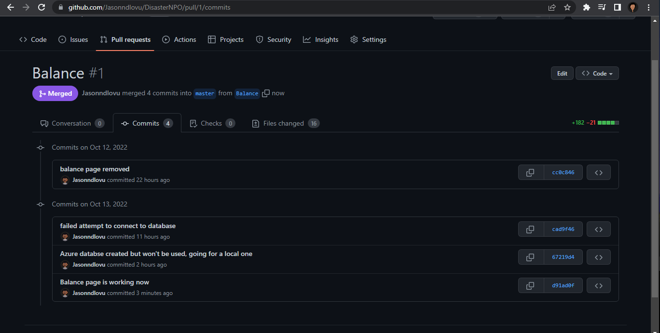

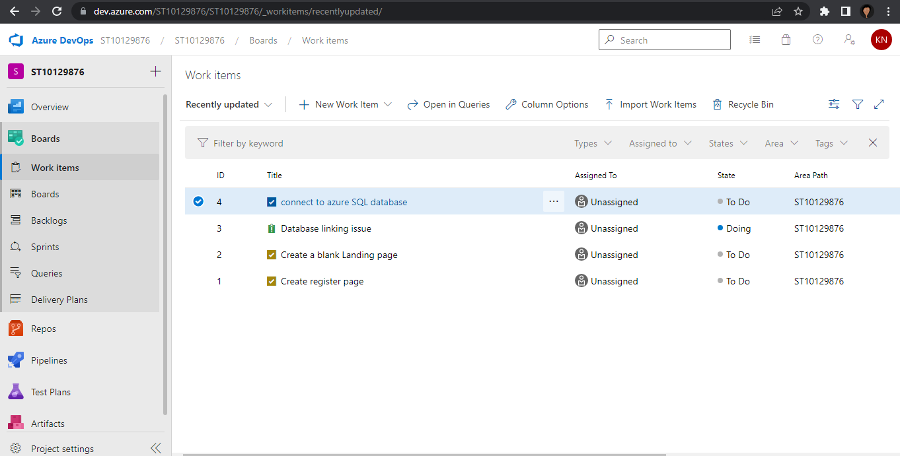

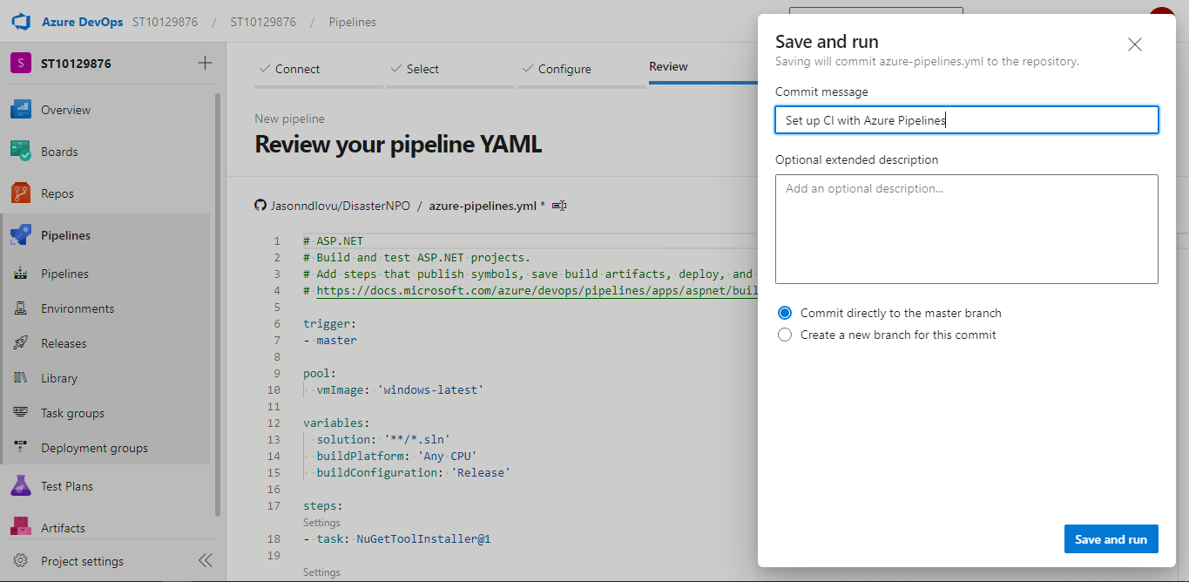

Pages

